**Basic Assignment**

**Atharva Shukla**

**1) MongoDB Exercise in mongo shell Connect to a running mongo instance, use a database named mongo_practice. Document all your queries in a javascript file to use as a reference.**

**2) Insert the following documents into a movies collection.**

**3)** **Query / Find Documents query the movies collection to**

**1. get all documents**

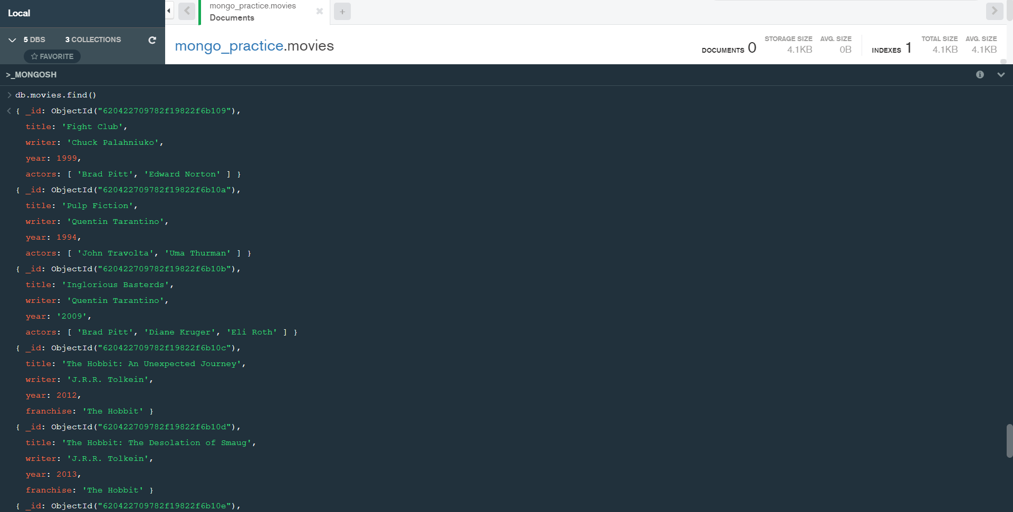**2. get all documents with writer set to "Quentin Tarantino"**

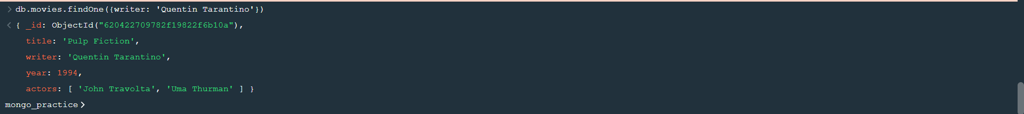

**4. get all documents with franchise set to "The Hobbit"**

**5. get all movies released in the 90s**

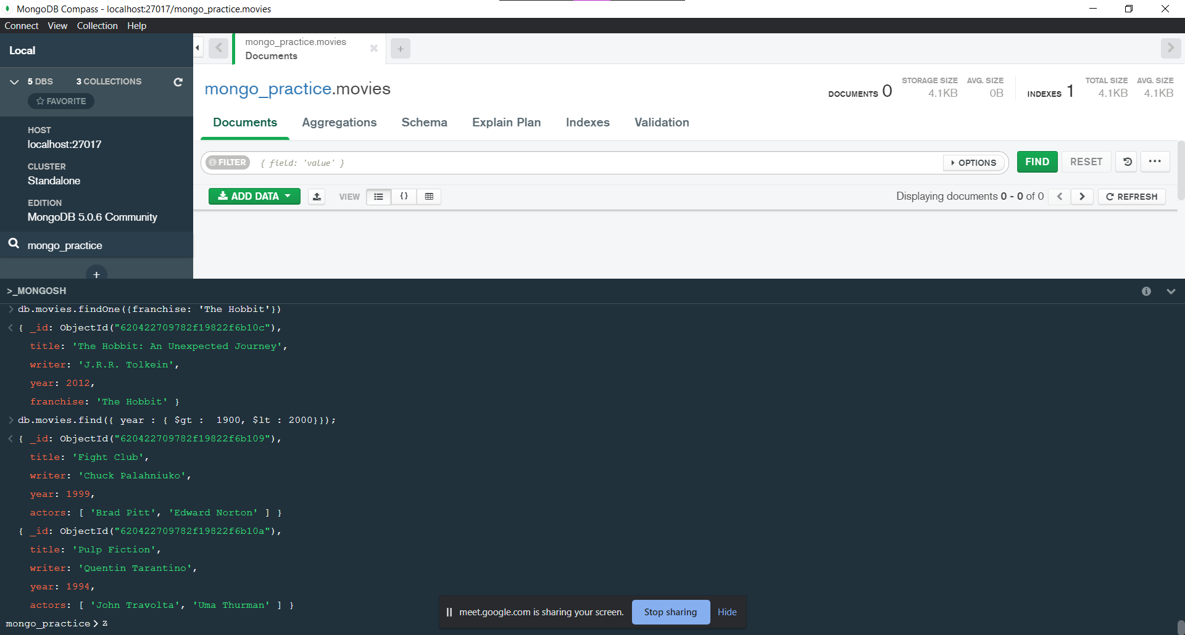

**1. add a synopsis to "The Hobbit: An Unexpected Journey" : "A reluctant hobbit, Bilbo Baggins, sets out to the Lonely Mountain with a spirited group of dwarves to reclaim their mountain home - and the gold within it - from the dragon Smaug."**

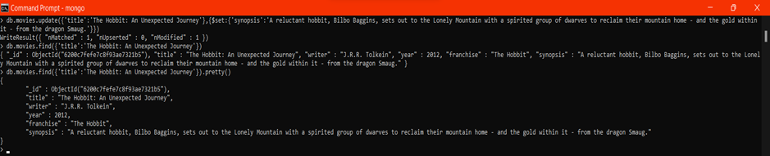

**2. add a synopsis to "The Hobbit: The Desolation of Smaug" : "The dwarves, along with Bilbo Baggins and Gandalf the Grey, continue their quest to reclaim Erebor, their homeland, from Smaug. Bilbo Baggins is in possession of a mysterious and magical ring."**

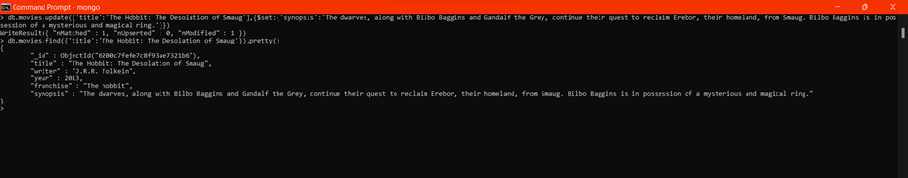

**3. add an actor named "Samuel L. Jackson" to the movie "Pulp Fiction**

# 

# **Text Search**

**1: find all movies that have a synopsis that contains the word "Bilbo**

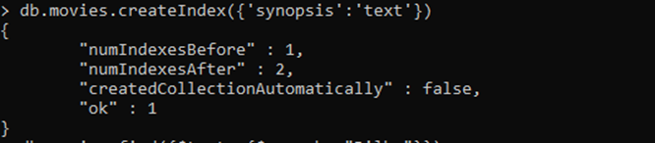

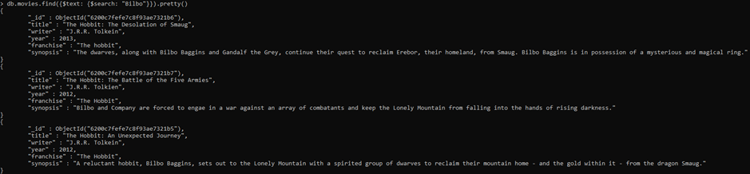

**2. find all movies that have a synopsis that contains the word "Gandalf"**

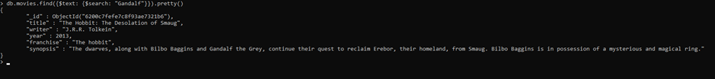

**3. find all movies that have a synopsis that contains the word "Bilbo" and not the word "Gandalf**

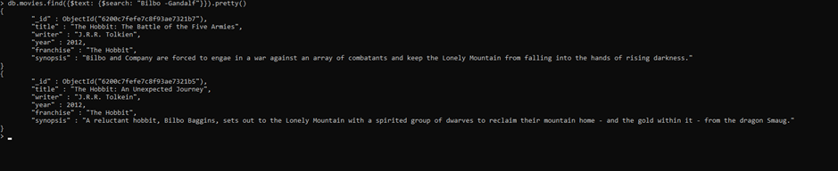

**4. find all movies that have a synopsis that contains the word "dwarves" or "hobbit"**

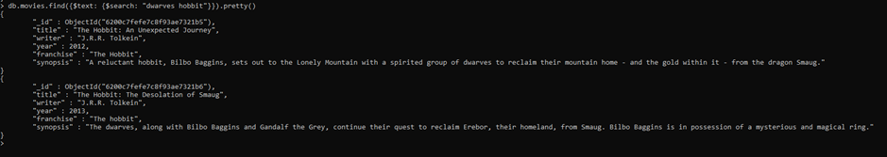**5. find all movies that have a synopsis that contains the word "gold" and "dragon"**

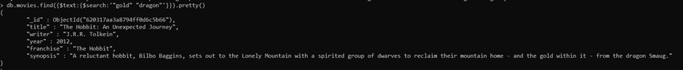**Delete Rows**

**1. delete the movie "Pee Wee Herman's Big Adventure"**

**2.delete the movie "Avatar"**

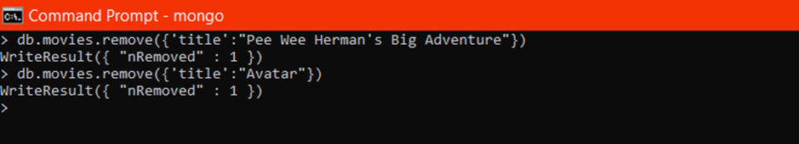

**Relationships**

**Insert the following documents into a users collection**

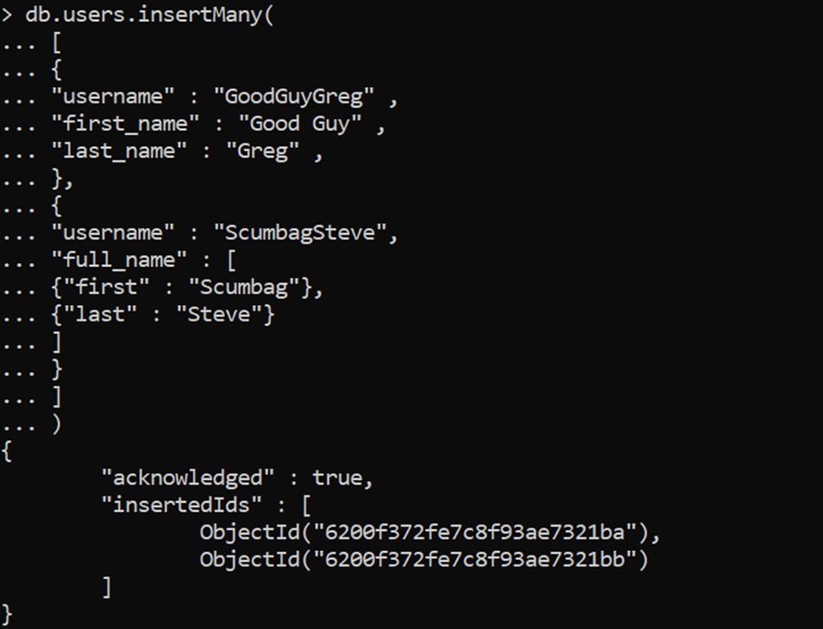

**Insert the following documents into a posts collection**

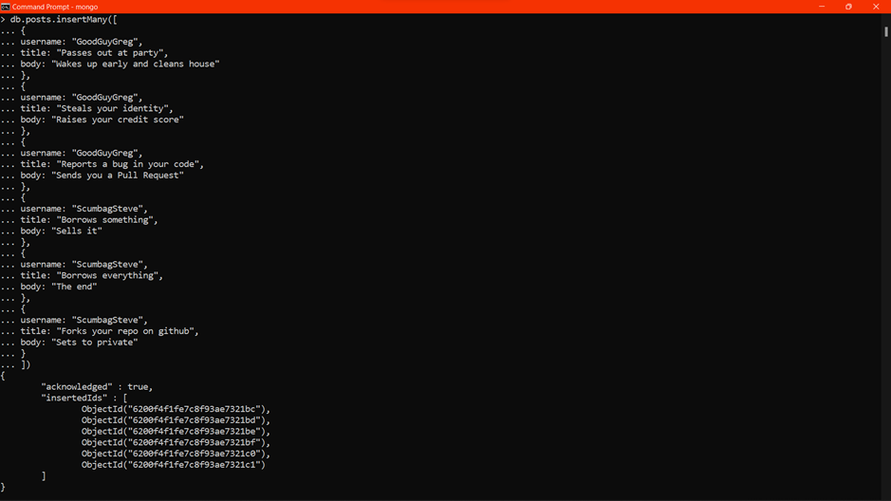

**Insert the following documents into a comments collection**

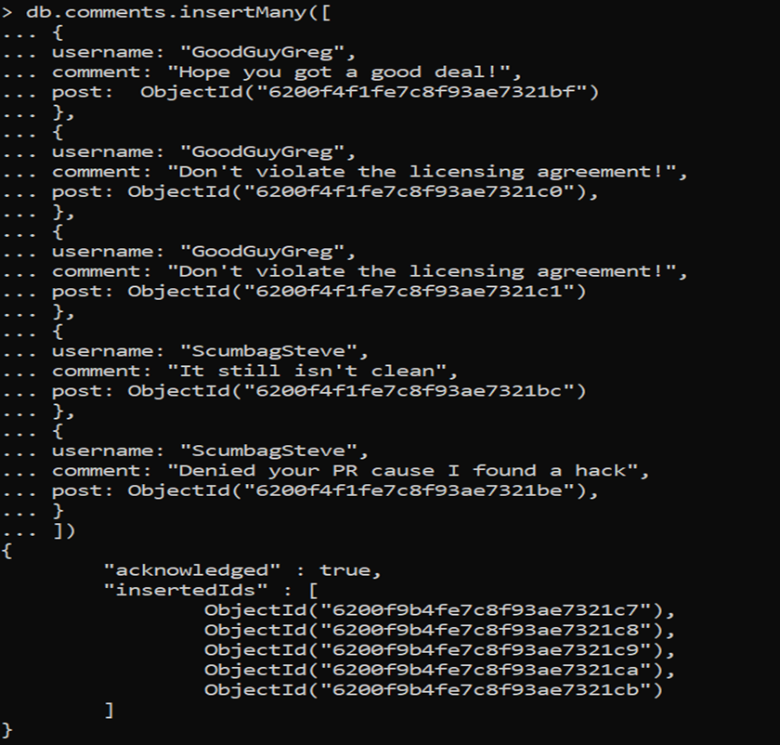

# **Querying related collections**

**Find all users**

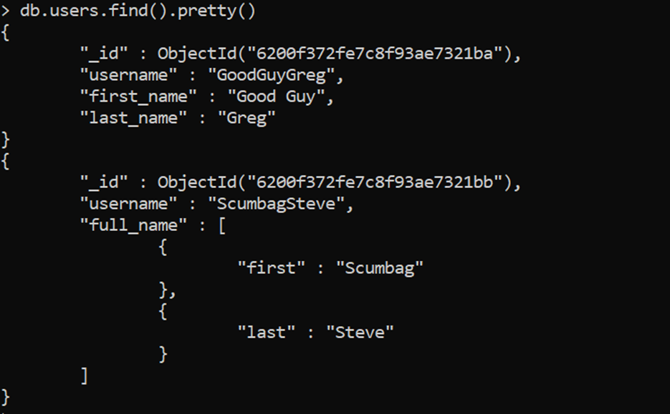

**Find all posts**

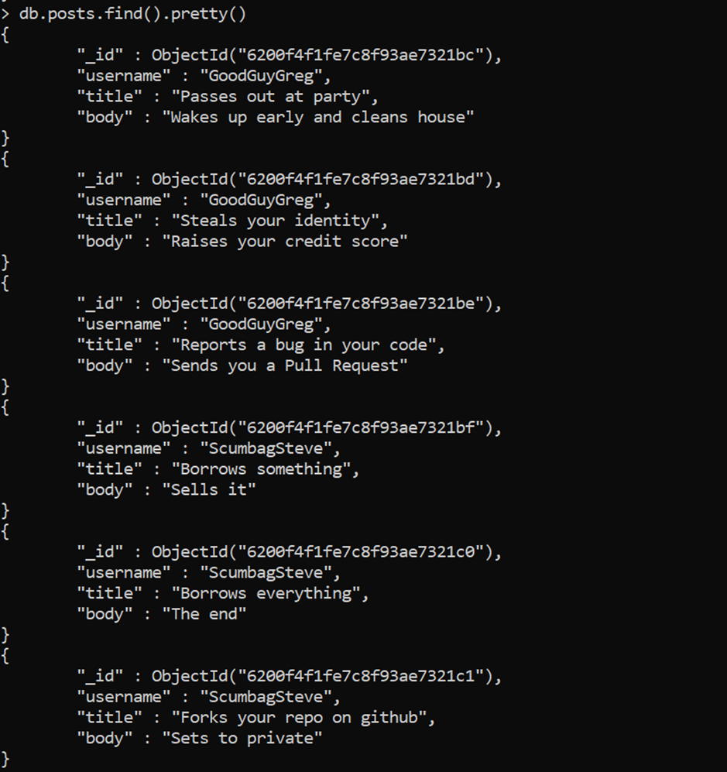

**Find all posts that was authored by "GoodGuyGreg"**

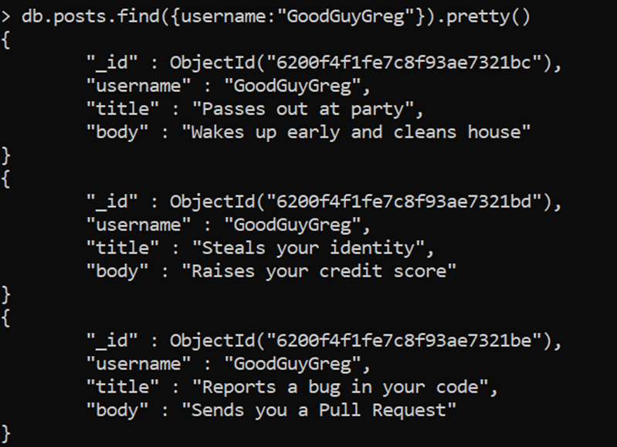

**Find all posts that was authored by "ScumbagSteve"**

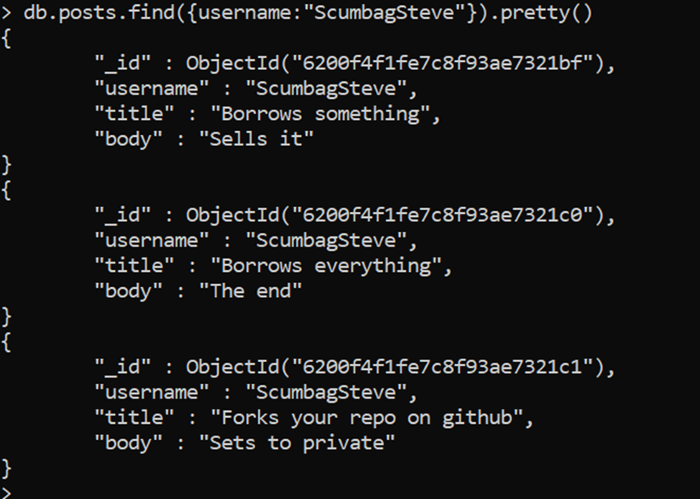

**Find all comments**

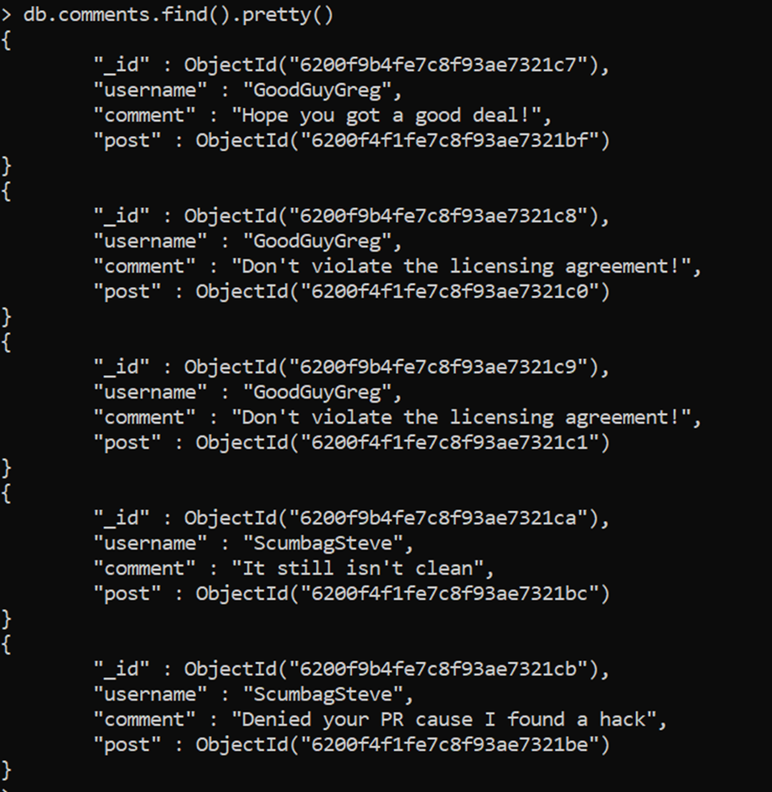

**find all comments that was authored by "GoodGuyGreg"**

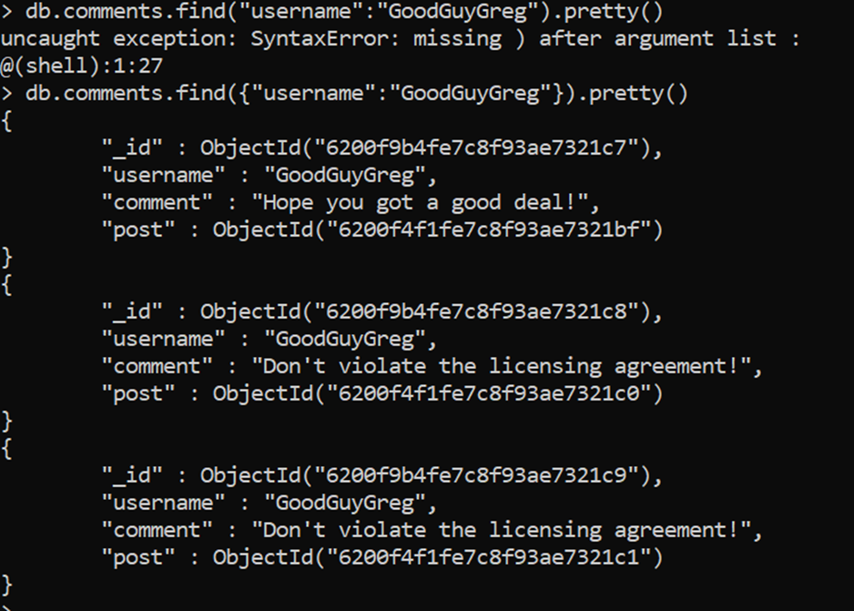

**find all comments that was authored by "ScumbagSteve"**

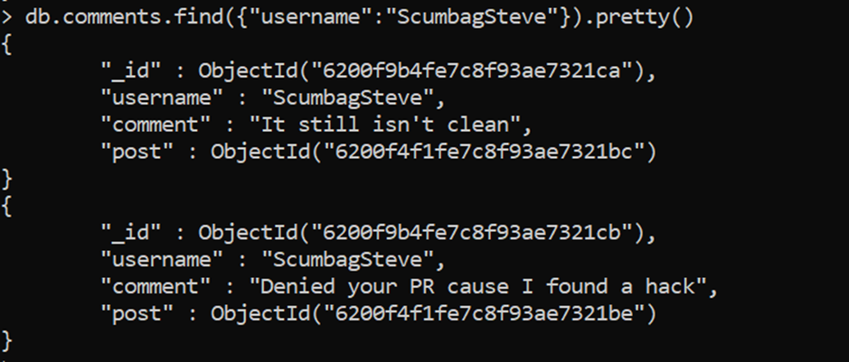

**find all comments belonging to the post "Reports a bug in your code"**

